Title of the Article
Name Surname^{1*}, Name Surname², Name Surname³
¹ Affiliation of the organization, adress, country, * corresponding author’s email
² Affiliation of the organization, adress, country
Abstract
Text text text text text text text text text text text text text text text text text text text text text text text text text text text text text text text text text text text text text text text text text text text text text text text text text text text text.
Key words: text; text; text; text; text
Introduction
Text text text text text text text text text text text text text text text text text text text text text text text text text text text text text text text text.
Material and methods
Text text text text text text text text text text text text text text text text text text text text text text text text text text text text text text text text.
Results
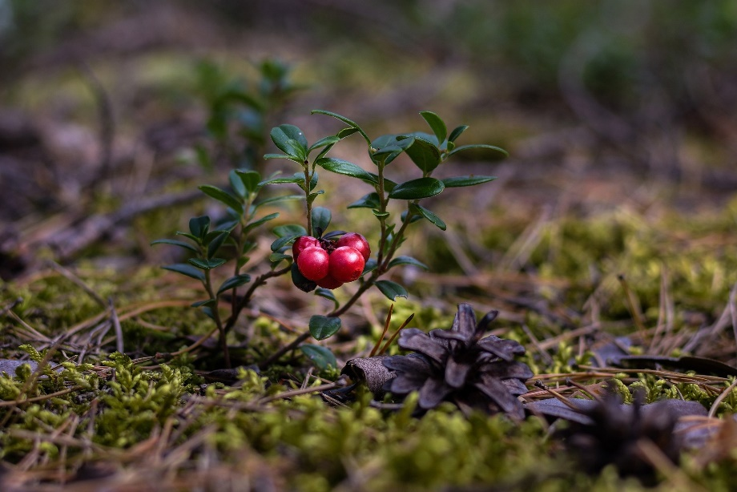
Text text text text text text text text text text text text text text text text text text text text text text text text text text text text text text text text.
Figure 1: Cranberry (Vaccinium vitis-idaea L.), author’s photo
Discussion
Text text text text text text text text text text text text text text text text text text text text text text text text text text text text text text text text.
Text text text text text text text text text text text text text text text text text text text text text text text text text text text text text text text text.
Summary
Text text text text text text text text text text text text text text text text text text text text text text text text text text text text text text text text.
References: e.g. Kučera A, Samec P, Bajer A, Skene K, Vichta T, Vranová V, Meena R, Datta R. Forest Soil Water in Landscape Context. 2021. In: Soil Moisture Importance. Londýn: InTechOpen, 1--28. https://doi.org/10.5772/intechopen.93003
Acknowledgement: Text text text text text text text text.

